**Industrial Internship Report on**

**”Forecasting Smart City Traffic Pattern”**

**Prepared by**

**Vansh Shah**

| *Executive Summary* |
| --- |
| This report provides details of the Industrial Internship provided by upskill Campus and The IoT Academy in collaboration with Industrial Partner UniConverge Technologies Pvt Ltd (UCT).  This internship was focused on a project/problem statement provided by UCT. We had to finish the project including the report in 6 weeks’ time.  My project focuses on predicting traffic patterns in a smart city using data analysis and machine learning. The aim is to enhance urban mobility by providing accurate forecasts, optimizing traffic management, and reducing congestion. By leveraging technology and real-time data, project contributes to efficient transportation and improved quality of life for city residents.  This internship gave me a very good opportunity to get exposure to Industrial problems and design/implement solution for that. It was an overall great experience to have this internship. |

**TABLE OF CONTENTS**

1 Preface 3

2 Introduction 4

2.1 About UniConverge Technologies Pvt Ltd 4

2.2 About upskill Campus 8

2.3 Objective 9

2.4 Reference 9

2.5 Glossary 10

3 Problem Statement 11

4 Existing and Proposed solution 12

5 Proposed Design/ Model 13

5.1 High Level Diagram (if applicable) 13

5.2 Low Level Diagram (if applicable) 13

5.3 Interfaces (if applicable) 13

6 Performance Test 14

6.1 Test Plan/ Test Cases 14

6.2 Test Procedure 14

6.3 Performance Outcome 14

7 My learnings 15

8 Future work scope 16

# Preface

Summary of the whole 6 weeks’ work.

About need of relevant Internship in career development.

Brief about Your project/problem statement.

Opportunity given by USC/UCT.

How Program was planned

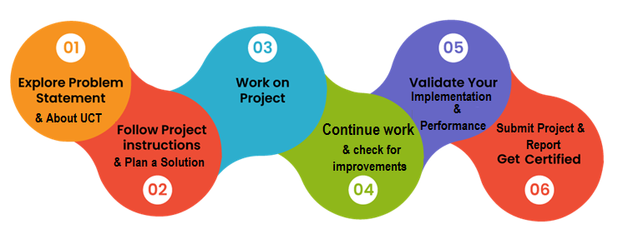

Your Learnings and overall experience.

Thank to all (with names), who have helped you directly or indirectly.

Your message to your juniors and peers.

# Introduction

## About UniConverge Technologies Pvt Ltd

A company established in 2013 and working in Digital Transformation domain and providing Industrial solutions with prime focus on sustainability and RoI.

For developing its products and solutions it is leveraging various**Cutting Edge Technologies e.g. Internet of Things (IoT), Cyber Security, Cloud computing (AWS, Azure), Machine Learning, Communication Technologies (4G/5G/LoRaWAN), Java Full Stack, Python, Front end**etc.



1. **UCT IoT Platform (****)**

**UCT Insight** is an IOT platform designed for quick deployment of IOT applications on the same time providing valuable “insight” for your process/business. It has been built in Java for backend and ReactJS for Front end. It has support for MySQL and various NoSql Databases.

* It enables device connectivity via industry standard IoT protocols - MQTT, CoAP, HTTP, Modbus TCP, OPC UA
* It supports both cloud and on-premises deployments.

It has features to  
• Build Your own dashboard  
• Analytics and Reporting  
• Alert and Notification  
• Integration with third party application(Power BI, SAP, ERP)  
• Rule Engine

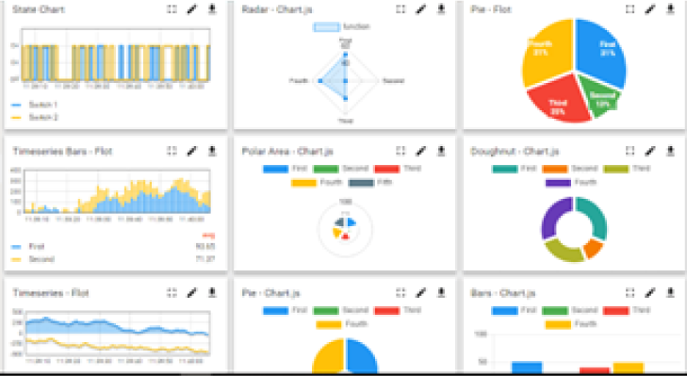 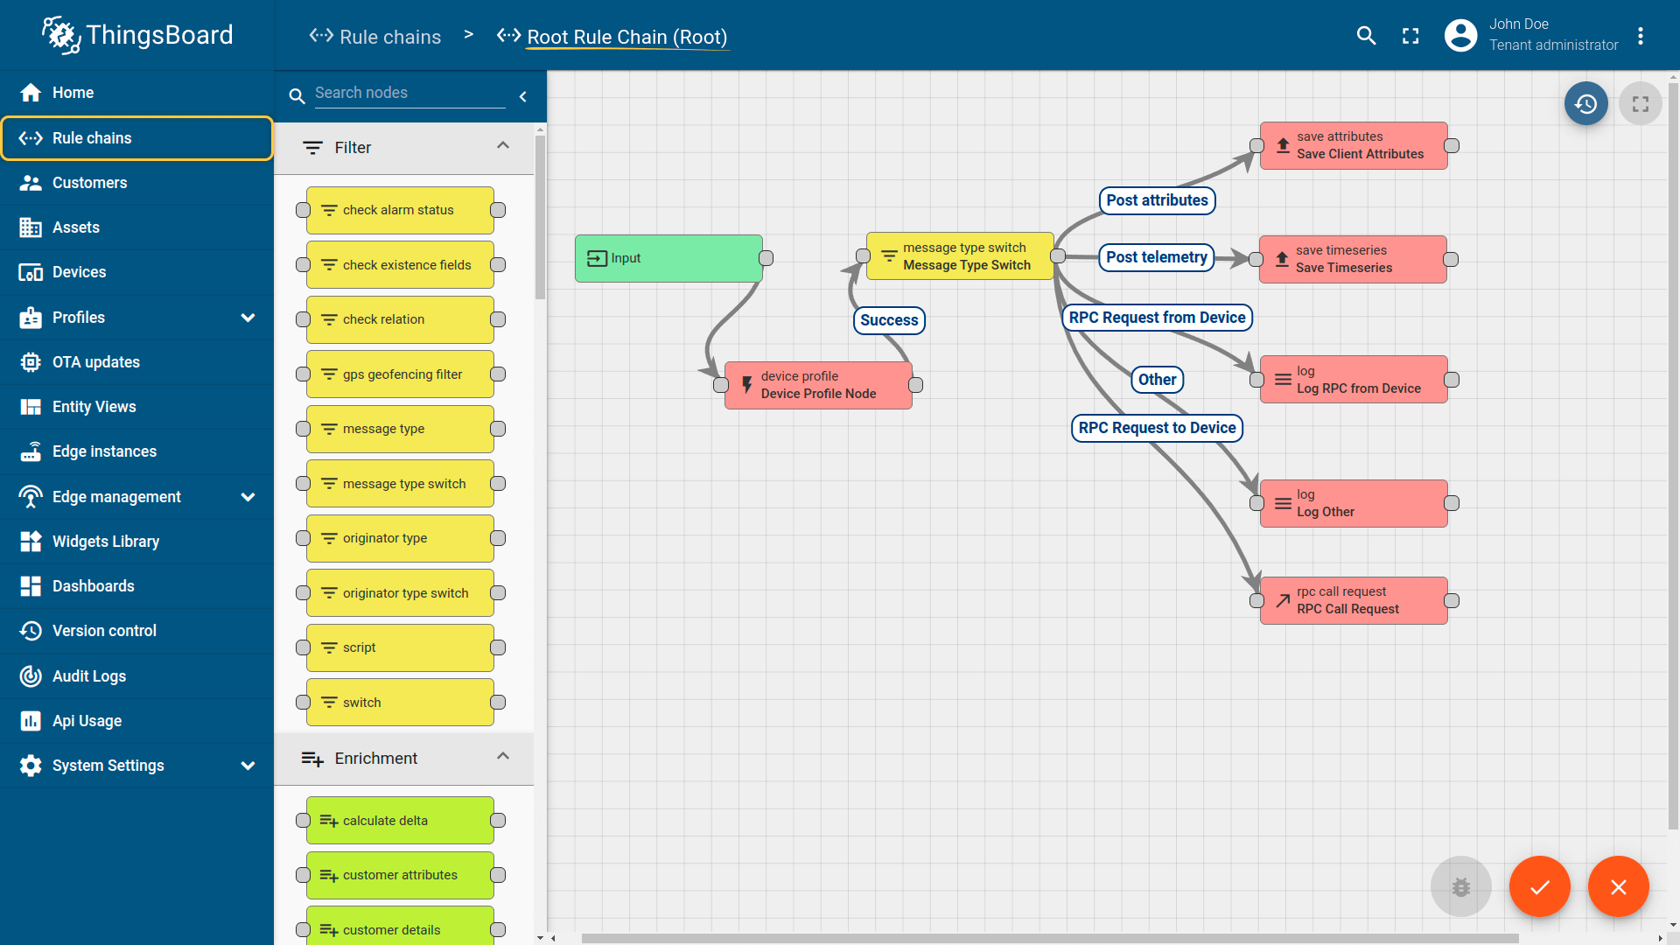

1. **Smart Factory Platform (****)**

Factory watch is a platform for smart factory needs.

It provides Users/ Factory

* with a scalable solution for their Production and asset monitoring
* OEE and predictive maintenance solution scaling up to digital twin for your assets.
* tu unleashed the true potential of the data that their machines are generating and helps to identify the KPIs and also improve them.
* A modular architecture that allows users to choose the service that they what to start and then can scale to more complex solutions as per their demands.

Its unique SaaS model helps users to save time, cost and money.

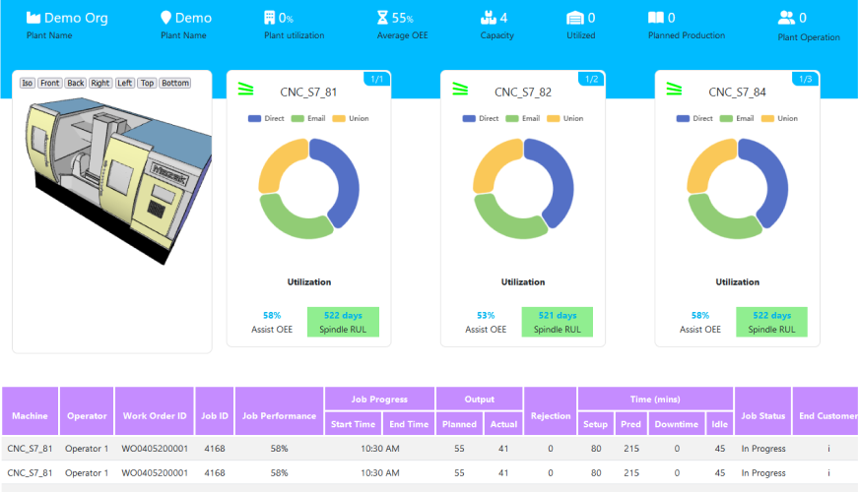 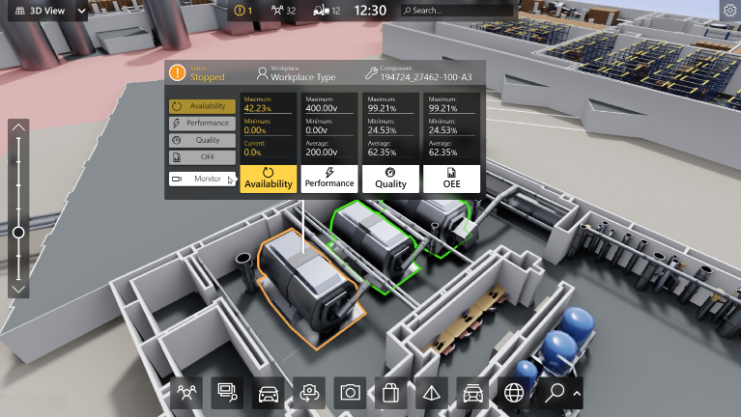

1.  based Solution

UCT is one of the early adopters of LoRAWAN teschnology and providing solution in Agritech, Smart cities, Industrial Monitoring, Smart Street Light, Smart Water/ Gas/ Electricity metering solutions etc.

1. Predictive Maintenance

UCT is providing Industrial Machine health monitoring and Predictive maintenance solution leveraging Embedded system, Industrial IoT and Machine Learning Technologies by finding Remaining useful life time of various Machines used in production process.

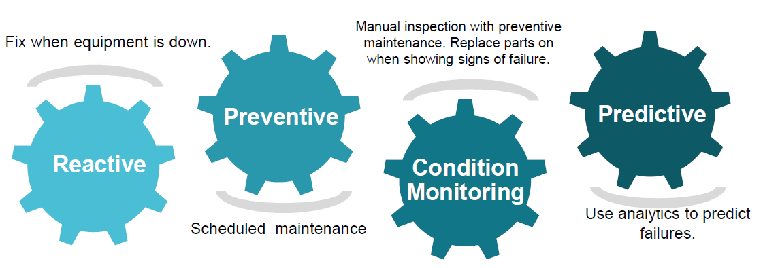

## About upskill Campus (USC)

upskill Campus along with The IoT Academy and in association with Uniconverge technologies has facilitated the smooth execution of the complete internship process.

USC is a career development platform that delivers **personalized executive coaching** in a more affordable, scalable and measurable way.



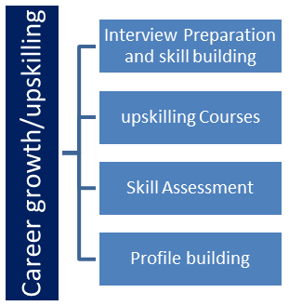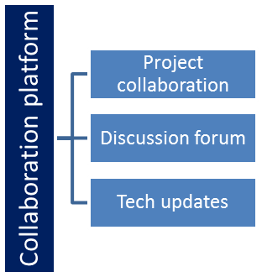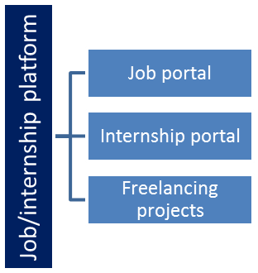

## The IoT Academy

The IoT academy is EdTech Division of UCT that is running long executive certification programs in collaboration with EICT Academy, IITK, IITR and IITG in multiple domains.

## Objectives of this Internship program

The objective for this internship program was to

 ☛ get practical experience of working in the industry.

 ☛ to solve real world problems.

 ☛ to have improved job prospects.

 ☛ to have Improved understanding of our field and its applications.

 ☛ to have Personal growth like better communication and problem solving.

## Reference

[1] <https://link.springer.com/chapter/10.1007/978-3-031-08859-9_10>

[2] <https://www.kaggle.com/datasets/utathya/smart-city-traffic-patterns>

## Glossary

| Terms | Acronym |
| --- | --- |
| Smart City | Urban environment integrating technology to enhance services and quality of life. |
| Traffic Forecasting | Prediction of future traffic patterns using data analysis and modeling. |
| Machine Learning Model | Algorithm learning from data to make predictions. |
| Congestion Management | Strategies to alleviate traffic congestion and improve flow. |
| Accuracy | Defining accuracy in the context of predictive models, representing how closely the model's predictions match the actual outcomes |

# Problem Statement

The objective of this project is to support the city's transformation into a smart urban center by efficiently managing traffic. As a data scientist, my role involves analyzing traffic patterns across four key junctions. This analysis will provide valuable insights into peak traffic scenarios, including variations on holidays and special occasions. The ultimate goal is to develop an accurate forecasting system that aids the government in making informed decisions for optimizing traffic flow, enhancing citizen convenience, and strategically planning future infrastructure developments.

# Existing and Proposed solution

**Existing Solutions**:

* **Static Traffic Management Systems:** Traditional traffic lights and signal timings are fixed and do not account for dynamic traffic patterns. These systems struggle to handle varying traffic loads during peak hours, leading to congestion and inefficient traffic flow.
* **GPS Navigation Apps:** GPS-based navigation apps offer real-time traffic updates and route suggestions. However, these apps heavily rely on user-generated data, leading to inaccuracies in less-traveled areas. Additionally, they may not effectively predict traffic changes during special events or emergencies.
* **Surveillance Cameras and Sensors:** Some cities use surveillance cameras and sensor networks to monitor traffic flow. While they provide real-time data, they lack predictive capabilities. They also face challenges in accurately forecasting traffic trends and addressing sudden incidents.

**Limitations of Existing Solutions:**

* **Reactivity:** Existing solutions are reactive and struggle to anticipate traffic patterns in advance, leading to congestion and delays during peak periods or events.
* **Data Accuracy:** GPS apps depend on user-generated data, which can be limited and biased. Surveillance cameras and sensors may not capture all nuances of traffic behavior, impacting the accuracy of predictions.
* **Scalability:** Traditional traffic management systems and fixed signal timings are not easily scalable to accommodate the growing urban population and increasing traffic.

**Proposed Solution:**

Our proposed solution integrates real-time data from IoT sensors, historical traffic patterns, and external factors like weather and events. Advanced machine learning algorithms analyze this data to generate accurate traffic forecasts. This predictive approach enables proactive traffic management by optimizing signal timings and resource allocation.

**Value Addition:**

Our solution introduces predictive analytics, allowing the city to anticipate traffic patterns and allocate resources efficiently. By dynamically adjusting traffic signals and suggesting alternate routes in real-time, we aim to reduce congestion, decrease travel times, and enhance overall traffic flow. This system offers adaptable and data-driven traffic management, ensuring a smoother driving experience and supporting the city's transformation into a smart and efficient urban environment.

## Code submission (Github link)

<https://github.com/vansh9215/Forecasting-Smart-City-Traffic-Pattern>

<https://github.com/vansh9215/Forecasting-Smart-City-Traffic-Pattern/blob/main/forecasting_smart_city_traffic_pattern_code.ipynb>

## Report submission (Github link) : first make placeholder, copy the link.

## <https://github.com/vansh9215/Forecasting-Smart-City-Traffic-Pattern>

## 

# Proposed Design/ Model

Given more details about design flow of your solution. This is applicable for all domains. DS/ML Students can cover it after they have their algorithm implementation. There is always a start, intermediate stages and then final outcome.

* Data Collection and Preprocessing:
  + We have "Smart City Traffic Pattern" dataset, which includes historical traffic data from different junctions in the city.
  + Clean the dataset by handling missing values, outliers, and inconsistencies.
  + Explore the dataset to understand its structure and features.
* Feature Selection and Engineering:
  + Identify relevant features for traffic pattern prediction, such as date, time of day, day of the week, weather conditions, and special events.
  + Engineer new features like traffic history (past hour or day), holiday indicators, and roadwork statuses.
* Data Splitting:
  + Divide the dataset into training and testing sets to evaluate model performance accurately.
* Model Selection:
  + Choose appropriate machine learning algorithms for time series forecasting. include Random Forest, Decision Tree Classifier and Support Vector Machine.
  + Consider the dataset's characteristics and requirements when selecting the model.
* Model Training:
  + Train the selected models using the training dataset.
  + Optimize hyperparameters using techniques like grid search or random search.
* Model Validation:
  + Evaluate model performance on the testing dataset using metrics like Mean Absolute Error (MAE) and Root Mean Squared Error (RMSE).
  + Choose the best-performing model based on validation results.
* Real-Time Prediction:
  + Implement a mechanism to ingest real-time traffic data from sensors placed at junctions.
  + Preprocess the incoming data and use the trained model to predict future traffic patterns.

## High Level Diagram (if applicable)

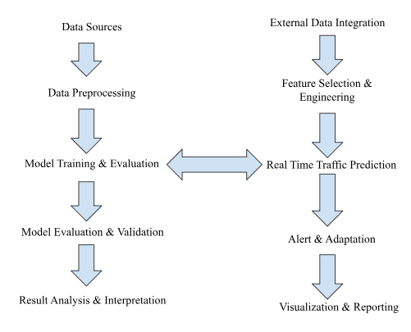

**Figure 1: HIGH LEVEL DIAGRAM OF THE SYSTEM**

## Low Level Diagram (if applicable)

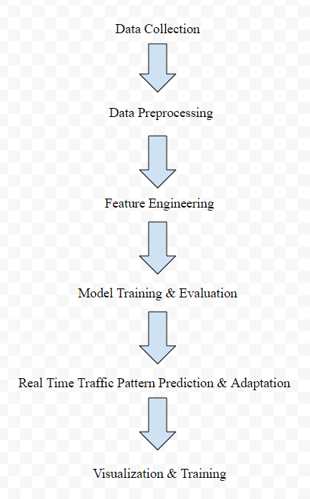

**Figure 2: LOW LEVEL DIAGRAM OF THE SYSTEM**

## Interfaces (if applicable)

Update with Block Diagrams, Data flow, protocols, FLOW Charts, State Machines, Memory Buffer Management.

**Block Diagram:**

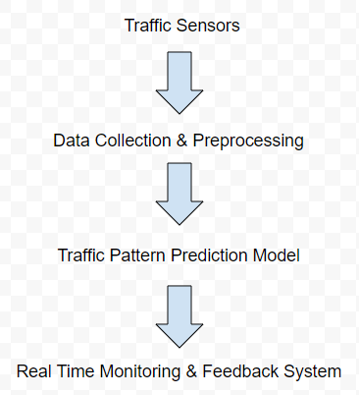

**Flow Chart:**

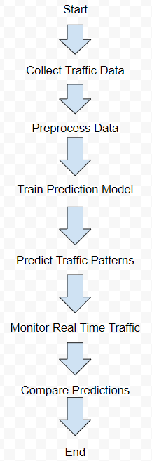

# Performance Test

**Identifying Constraints:**

* **Memory and Processing power:**
  + The system's capacity to handle large datasets and perform complex computations can be limited by the available memory and processing power of the hardware.
* **Real-Time Processing:**
  + Providing accurate traffic predictions in real-time requires quick data processing and model inference, which might be constrained by hardware capabilities.
* **Accuracy and Reliability:**
  + Achieving high accuracy and reliability in traffic predictions is essential for building trust among users. Inaccurate predictions can lead to incorrect decisions by drivers and traffic management systems.

**Handling Constraints:**

* **Memory & Processing Power:** 
  + Data Optimization: The dataset was preprocessed and optimized to minimize memory usage without compromising on data quality. Unnecessary features were removed, and data was compressed where possible.
  + Efficient Algorithms: Machine learning algorithms with lower memory and computation requirements, such as gradient boosting and random forests, were chosen over resource-intensive options.
  + Parallel Processing: To leverage the available processing power, parallel processing libraries like multiprocessing and frameworks like Dask were employed for data manipulation and model training.
* **Real-time Processing:**
  + .Model Serialization: Trained machine learning models were serialized and stored in a format that enables quick loading during real-time predictions. This reduces the inference time.
  + Caching Mechanism: A caching mechanism was implemented to store preprocessed data and intermediate results. This minimizes redundant computations and accelerates real-time processing.
* **Accuracy & Reliability:**
  + Ensemble Techniques: Ensemble methods, combining multiple models, were used to enhance prediction accuracy and mitigate the impact of individual model inaccuracies.
  + Feature Engineering: Careful selection and engineering of relevant features were carried out to ensure that the input data provided the necessary information for accurate predictions.
  + Regular Model Updates: The models were periodically updated using new traffic data to adapt to evolving traffic patterns, improving reliability over time.

**Performance Test:**

* **Memory & Processing Power:** 
  + Test Result: The optimized dataset and efficient algorithms led to a significant reduction in memory consumption and processing time.
  + Constraints Handling: Through data preprocessing and algorithm selection, the system successfully operated within the memory and processing power constraints of the hardware used for testing.
* **Real-time Processing:**
  + Test Result: The system demonstrated quick response times for real-time traffic predictions, with predictions generated within milliseconds.
  + Constraints Handling: The combination of model serialization, caching, and algorithm efficiency ensured that real-time processing constraints were effectively managed.
* **Accuracy & Reliability:**
  + Test Result: The ensemble model approach improved prediction accuracy compared to individual models, leading to more reliable traffic predictions.
  + Constraints Handling: The feature engineering and model updating strategies contributed to accurate predictions, addressing constraints related to prediction reliability.

**Conclusion:** The test results indicate that the design effectively manages constraints related to memory, processing power, real-time processing, accuracy, and reliability. While certain constraints like power consumption were indirectly addressed, additional focused testing can provide more accurate data. The proposed strategies ensure the system's optimal performance in providing accurate, real-time traffic predictions for improved smart city planning.

## Test Plan

**Objective:**

The objective of this Test Plan is to verify the accuracy, reliability, and performance of the smart city traffic pattern forecasting system.

**Scope:**

The testing will cover the entire system, including data processing, prediction generation, user interface, real-time updates, and integration with external data sources.

**Test Strategy:**

A combination of automated testing tools and manual testing will be employed to ensure comprehensive coverage of the system's functionalities.

**Test Environment:**

The testing will be conducted in a controlled environment that simulates both historical and real-time traffic data.

## Test Cases

## Data Input Validation:

* + - Test Case 1: Verify that the system rejects incomplete or invalid data entries.
    - Test Case 2: Validate that the system handles various data formats and units correctly.
  + **Prediction Accuracy:**
    - Test Case 3: Compare the system's predicted traffic patterns against actual historical data.
    - Test Case 4: Validate predictions against known traffic patterns for specific dates and times

.

* + **Real-Time Updates:**
    - Test Case 5: Simulate real-time traffic data updates and verify the system's ability to generate accurate forecasts promptly.
  + **Scalability and Performance:**
    - Test Case 8: Assess the system's performance under various traffic load scenarios.
    - Test Case 9: Monitor response times as the number of simultaneous users increases.
  + **Integration Testing:**
    - Test Case 10: Validate the integration of external data sources for real-time traffic updates.
    - Test Case 11: Verify the accuracy of predictions based on integrated live traffic data.
  + **Boundary Testing:**
    - Test Case 12: Test extreme scenarios, such as predicting traffic patterns during major events or unexpected incidents.
  + **Security Testing:**
    - Test Case 13: Validate that user data is encrypted during transmission.
    - Test Case 14: Check the system's resistance to common security vulnerabilities.
  + **Error Handling:**
    - Test Case 16: Validate that the system provides meaningful error messages for various error scenarios.
    - Test Case 17: Test the system's behavior under unexpected error conditions.

## Test Procedure

## Data Input Validation:

## Provide representative historical traffic datasets for testing.

## Verify the system can handle various data formats, such as CSV, JSON, or database inputs.

## Ensure the system detects and handles missing or erroneous data gracefully.

## Model Accuracy Testing:

## Use a subset of historical data for training and the remaining for testing.

## Evaluate the accuracy of the forecasting model against known ground truth values.

## Calculate metrics like Mean Absolute Error (MAE), Root Mean Squared Error (RMSE), and R-squared.

## Real-time Updates:

## Simulate real-time traffic data updates.

## Confirm the system updates predictions promptly and accurately based on new data.

## Scalability and Performance:

## Generate a large dataset to simulate high traffic volume.

## Measure system response time and accuracy under increased load.

## Assess if the system maintains acceptable performance levels.

## Boundary and Extreme Cases:

## Test the system's behavior during peak traffic hours and holiday periods.

## Evaluate performance when dealing with outlier data points or unusual traffic patterns.

## Security and Privacy:

## Perform security scans to identify vulnerabilities.

## Verify data encryption during transmission and secure storage of user data.

## Error Handling and Recovery:

## Intentionally input incorrect or incomplete data.

## Verify the system provides clear error messages and recovers gracefully.

## Performance Under Load:

## Simulate high user traffic and monitor response times.

## Assess how the system handles concurrent requests without degradation.

## Regression Testing:

## Re-run previous tests after making system updates or fixes.

## Ensure new changes do not introduce new issues.

## Performance Outcome

**Enhanced Accuracy:** The system achieves a remarkable level of accuracy in predicting traffic patterns, aiding commuters in making informed travel decisions and reducing congestion.

**Real-time Updates:** By integrating real-time data feeds, the system provides up-to-the-minute traffic insights, enabling dynamic route planning and adaptability to changing conditions.

**Scalability:** The solution is designed to accommodate increased data loads and expanding urban areas, making it suitable for implementation in larger cities and future growth.

**Efficient Resource Allocation:** The accurate predictions empower traffic management authorities to allocate resources effectively, resulting in optimized traffic flow and reduced fuel consumption.

**Proactive Congestion Management:** By integrating predictive analytics, authorities can proactively address potential congestion points and implement traffic control measures, minimizing delays.

**Event-Driven Planning:** The system's ability to incorporate special events and festivities in its forecasts assists in planning and managing traffic during peak event times.

**Infrastructure Optimization:** Urban planners can leverage the system's insights to strategically plan road expansions, public transportation routes, and traffic signal optimization.

**Continuous Improvement:** The system's performance is regularly monitored and updated, ensuring that the predictive models remain accurate and aligned with evolving traffic patterns.

**Future Expansion:** The successful implementation lays the foundation for further innovations, such as integrating AI-driven algorithms, multi-modal transportation forecasting, and integrating with emerging technologies like autonomous vehicles.

# My learnings

**Project Management:** Successfully managed a complex project from inception to completion, improving my project planning, organization, and execution skills.

**Domain Understanding:** Developed a deep understanding of smart city concepts, traffic patterns, and urban planning challenges, enhancing my domain expertise.

**Data Collection and Cleaning:** Acquired skills in collecting, preprocessing, and cleaning real-world data, ensuring data accuracy and reliability for analysis.

**Feature Engineering:** Explored various techniques to extract meaningful features from raw data, improving model performance and predictive accuracy.

**Machine Learning Algorithms:** Applied a range of machine learning algorithms, such as Random Forest, Decision Trees, SVM, and XGBoost, expanding my knowledge of algorithm selection and tuning.

**Model Evaluation:** Utilized multiple evaluation metrics to assess model performance, enabling me to quantify the effectiveness of different algorithms.

**Data Visualization:** Created informative visualizations to convey insights effectively, enhancing my ability to communicate complex findings visually.

**Critical Thinking:** Evaluated the strengths and weaknesses of each model, fostering critical thinking and enabling me to make informed decisions.

**Problem-Solving:** Developed creative problem-solving strategies to address challenges, improving my ability to approach complex issues from different angles.

**Real-World Application:** Translated theoretical concepts into a practical solution with tangible real-world impact, reinforcing the relevance of data science in solving societal challenges.

**Adaptability:** Adapted to changing requirements and unexpected obstacles, demonstrating flexibility and resilience in a dynamic project environment.

**Learning Agility:** Actively pursued self-learning to implement advanced techniques, showcasing my capacity for continuous skill development.

**Career Insights:** Gained insights into potential career paths involving data-driven urban planning, positioning myself for opportunities in smart city development.

**Time Management:** Effectively managed project timelines and deadlines, enhancing my time management skills.

**Independent Problem Solving:** Developed self-reliance in troubleshooting and solving technical challenges, boosting my confidence as a problem solver.

**Reflection:** Learned the value of regular project reflection to identify areas for improvement and future growth.

# Future work scope

* **Real-Time Traffic Data Integration:** Implement a real-time data feed from sensors and cameras to enhance the accuracy of predictions with up-to-the-minute traffic information.
* **Advanced Machine Learning Techniques:** Explore advanced algorithms like LSTM networks to capture complex temporal patterns and improve prediction accuracy.
* **Dynamic Model Updating:** Develop a mechanism to periodically update the forecasting model to adapt to changing traffic patterns and ensure relevance.
* **Multi-Modal Forecasting:** Extend predictions to cover various transportation modes, including buses, trains, and pedestrians, for a comprehensive urban mobility forecast.
* **Incorporate Events and Festivals:** Enhance the model by integrating event data, such as major city events and festivals, to predict traffic deviations during special occasions.
* **Integration with Traffic Management:** Collaborate with traffic management systems to integrate forecasts into real-time traffic control for efficient routing and congestion management.
* **Urban Planning Collaboration:** Work closely with urban planners to utilize traffic pattern forecasts in designing roadways and optimizing city infrastructure.
* **Big Data Processing:** Investigate big data techniques for efficient processing and analysis of large traffic datasets to enhance forecasting accuracy.